**Project Report**



**CS361L – Computer Networks (Lab)**

**Submitted by:**

**Arooj Fatima (2019-CS-102)**

**Vaniza Riaz (2019-CS-105)**

**Rimsha Zaib (2019-CS-113)**

**Ayesha Yaseen (2019-CS-117)**

**Department of Computer Science**

**University of Engineering and Technology, Lahore**

**Background of the Client**

**Name of organization:**

DevBatch Pvt Ltd

**Location of organization:**

144-A, Abu Bakr Bock Garden Town, Lahore

**Line of business:**

Developing Softwares(Business)

**Departments of Organization**

HR

Product development

Account and Finance

**Number of employees in each Department:**

HR _ 60

Product development _ 60

Account and Finance _ 60

**Networking Requirements**

|  |  |  |  |  |  |
| --- | --- | --- | --- | --- | --- |
| **Name of hardware** | **Purpose** | **Unit Price** | **Quantity** | **Total Price** | **Website URL link** |
| PC | For software development and communication | 50,000 | 150 | 7,500,000 | <https://galaxy.pk/store/dell-optiplex-3080-tower-ci3-10th-4gb-1tb-dvd/> |
| Laptop | For software development and communication | 65,500 | 100 | 6,550,000 | <https://galaxy.pk/store/lenovo-v15-celeron-4gb-1tb-hdd-15-6-hd-iron-grey-international-warranty/> |
| Smartphones | For communication | 28,000 | 50 | 1,400,000 | <https://www.whatmobile.com.pk/Infinix_Mobiles_Prices> |
| Printers | For printing | 10,000 | 10 | 100,000 | <https://www.shophive.com/computer-devices/printers> |
| Routers | For connecting the networks between different departments to provide communication | 3000 | 3 | 9,000 | <https://vmart.pk/product-category/wireless-networking-pakistan/wireless-routers-pakistan/> |
| Switches | To create a LAN network | 6000 | 3 | 18,000 | <https://www.mbcommunication.com.pk/312-gigabit-ethernet-switch> |
| Access Points | To provide network to the wireless devices (smartphones) | 5500 | 3 | 16,500 | <https://vmart.pk/product-category/wireless-networking-pakistan/wireless-access-points-pakistan/> |
| Servers | To allocate dynamic IP Addresses, to access internet through HTTP and to allow file exchange with FTP | 100,500 | 3 | 301,500 | <https://www.mega.pk/servers/> |

**IP addressing Scheme**

1. To save wasted addresses of Class C, classless IP addressing is used. Since each department has 60 users, the classless IP addressing would be as follows:

IP address for product department: 192.168.10.2

Network address: 192.168.10.0

Total number of users: 50 = 26 = 64

Total Usable IPs: 64 – 2 = 62

First IP: 192.168.10.1

Last IP: 192.168.10.62

Broadcast Address: First IP = 192.168.10.63

Subnet Mask: 255.255.255.1100 0000 = 255.255.255.192

IP address for product department = 192.168.10.2 / 26

IP address for HR department = 192.168.20.2 / 26

IP address for Account and Finance department= 192.168.30.2 / 26

1. Static IP addressing would be used to configure servers and routers whereas dynamic IP addressing would be used for all the floors
2. DHCP for product department:  
   Server IP Address: 192.168.10.2  
   Subnet Mask: 255.255.255.192  
   Gateway: 192.168.10.1  
   DNS Server: 192.168.40.3  
   Turn on services, assign the start IP address as 192.168.10.3  
   Configure all the PCs using DHCP and each will get a unique IP address within the range.

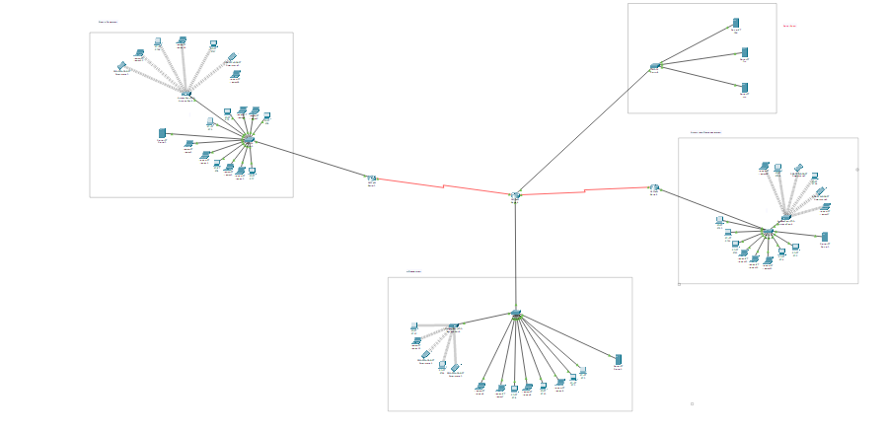

**Security Considerations**

**Security Threats:**

1. Internal Threats
2. Botnets
3. Viruses and Worms
4. Phishing Attacks
5. Derive-by download Attacks
6. Distributed Denial-of-Service(DDoS) Attacks
7. Malvertising

**Security Measures:**

1. Anti-Virus Software
2. Password authentication
3. Multifactor Authentication
4. Firewalls

**Wireless security configurations:**

**Product Department**

SSID: accesspoint1

Key: 1111111111

**HR Development**

SSID: accsesspoint2

Key: 2222222222

**Accounts and Finance**

SSID: accessspoint3

Key: 3333333333

**Network Topology:**

**Star Topology**

In each branch there is one central device (switch) and all the other devices are connected to it.

In router’s layout, Router 4 is acting as the central router and all the other devices (router and switches) are connected